Certificate of Appreciation
Awarded to

In recognition of your contribution to the community on behalf of
[Your organisation name & logo]
Presented on
International Volunteer Day
5th December 2018
Signatory  Position  Your Organisation |  | 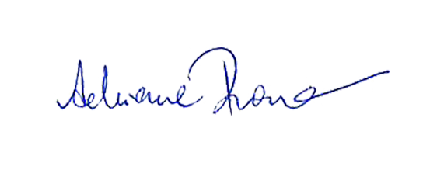  Adrienne Picone  Chief Executive Officer  Volunteering Australia

