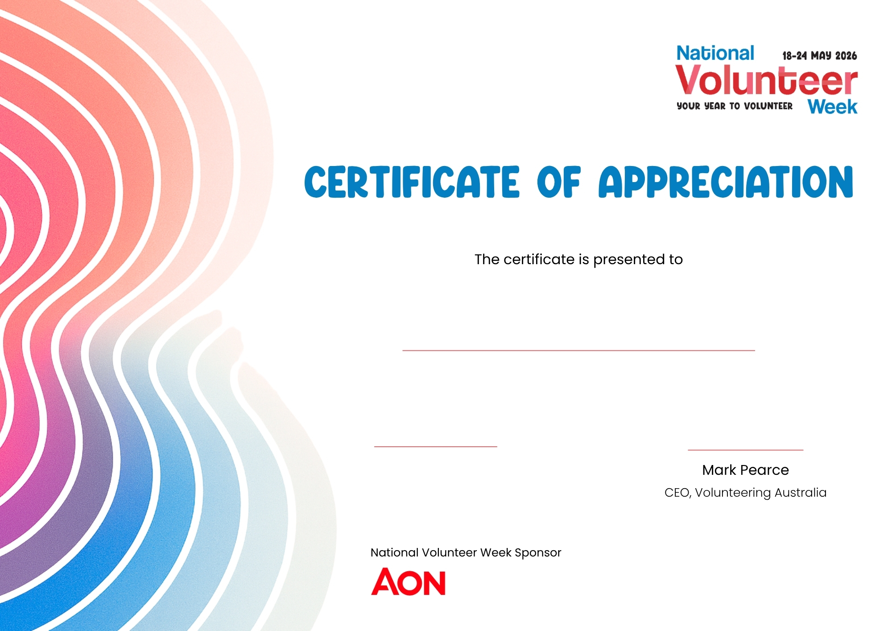
Signature Name
Title, Organisation
M Pearce

Name
Volunteer Name

